Christopher Wilson
7/15/2026
CS-660 Module Two Activity
- Construct a context-free grammar that includes multiple production rules.
Expression = Whole Math problem (ex. 3 + 5 + 5 x 9)
Term = piece of the expression that deals with multiplication and division (ex. 3 x 5, 6/2)
Factor = individual values being multiplied or a value inside parentheses (ex. 3 and 5 from 3 x 5, (2 + 4))
Number = any numeric value (ex. 100, 4, 2, 19)
Digit = Any number character from 0-9 (ex. 4, 5, 6, 7)

Context-free grammar:
Expression → Expression + Term
Expression → Expression - Term
Expression → Term

Term → Term * Factor
Term → Term / Factor
Term → Factor

Factor → (Expression)
Factor → Number

Number → Digit
Number → Digit Number

Digit → 0 | 1 | 2 | 3 | 4 | 5 | 6 | 7 | 8 | 9

- Define grammar rules that are logically consistent and appropriate for a simple arithmetic expression language.
The grammar rules define how valid arithmetic expressions are constructed within the language. The Expression rules allow addition and subtraction, while the Term rules allow multiplication and division. The Factor rules define the smallest components of an expression, such as numbers or expressions inside parentheses. The Number and Digit rules allow the creation of valid positive integers. These rules are logically consistent because they organize the structure of arithmetic expressions according to the standard mathematical order of operations, allowing the parser to interpret and evaluate expressions correctly.

- Compare formal grammar rules to the practical execution of expression evaluation.
The formal grammar rules explain how an arithmetic expression is structured, while practical execution shows how the computer evaluates the expression. The grammar separates different parts of the expression, such as Expressions for addition and subtraction, Terms for multiplication and division, and Factors for numbers or parentheses. When the interpreter runs, it uses these rules to create an AST and evaluate the expression in the correct order. For example, in 3 + 5 * 2, the grammar shows that multiplication is handled in the Term section, so the computer calculates 5 * 2 before adding 3.

- Identify a point of divergence between theoretical structure and real-world output.
A point of divergence between the theoretical grammar structure and real-world output is that the grammar only defines the structure of a valid expression, but it does not handle errors or meaning. For example, the grammar may allow an expression like 5 + 3, but the evaluator is responsible for actually calculating the result and handling issues such as invalid input or division by zero. The grammar describes how an expression should be built, while the interpreter determines the final output.

- Design a visual diagram that accurately represents the parsing structure of a sample expression.
- Label all grammar components in the diagram using appropriate terminology.

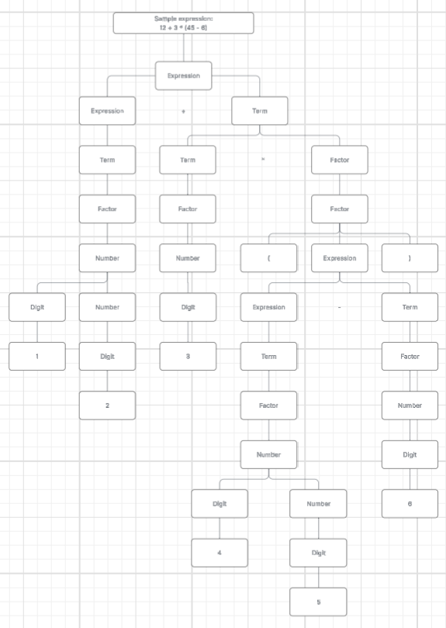
- Organize the diagram to reflect a clear parsing approach. Consider the following:
Top-down or bottom-up
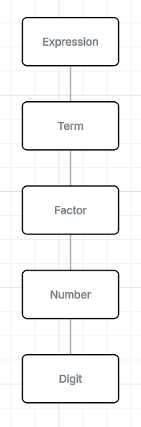
- Implement a parser that builds an accurate AST from valid input. Include the following:
- Screenshot of your implementation
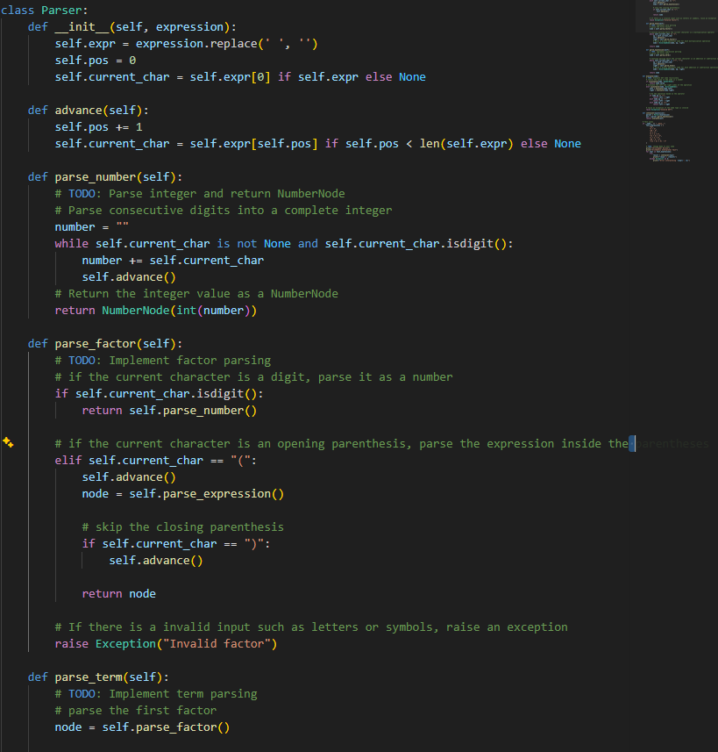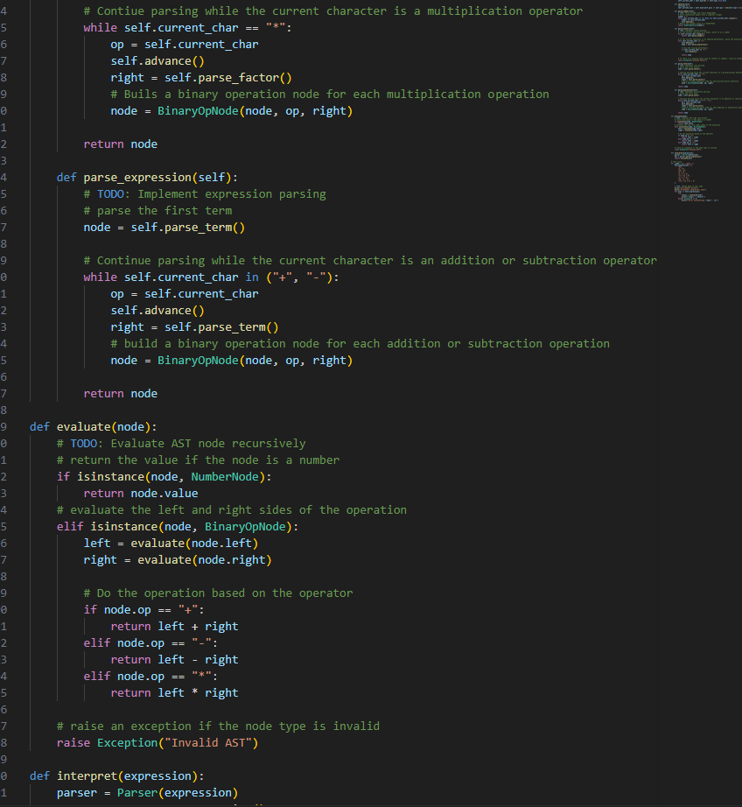
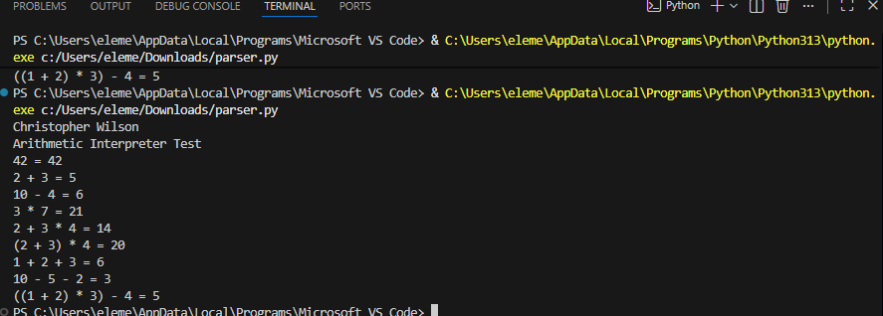

- Evaluate expressions by applying semantic rules to traverse the AST. Note: You may assume all expressions are valid.
The program evaluates an expression by recursively moving through the Abstract Syntax Tree. If the current node is a NumberNode, it returns the number stored in the node. If the current node is a BinaryOpNode, it first evaluates the left and right child nodes, then performs the operation stored in the node, such as addition, subtraction, or multiplication. This continues until the entire tree has been evaluated and the final answer is returned.

- Explain how the AST structure corresponds to the original grammar rules.
The AST is built by following the grammar rules defined for arithmetic expressions. The parse_number() function creates a NumberNode for each integer. The parse_factor() function handles numbers and expressions inside parentheses. The parse_term() function builds BinaryOpNode objects for multiplication, while the parse_expression() function builds BinaryOpNode objects for addition and subtraction. Since multiplication is parsed before addition and subtraction, the AST correctly follows the grammar and preserves the correct order of operations. Parentheses create nested parts of the tree, which are evaluated before the rest of the expression.

- Explain the structure of the constructed grammar.
The grammar is structured to separate each operation so it follows the order of operations. The expression rule handles addition and subtraction, the term rule handles multiplication, and the factor rule handles numbers and expressions inside of parentheses. The structure makes sure the parser follows the order of operations correctly, for example, multiplication should be first because term is processed before the expression.

- Describe how the diagram represents the parsing process.
The diagram represents the parsing process by breaking the arithmetic expressions into smaller parts and building the abstract syntax tree. The parsing process starts with a full expression, then moves through each grammar rule by separating into terms, factors, and numbers. Each operation becomes a node in the tree, with the numbers becoming the child nodes. The tree structure shows the order in which the operations would be evaluated.

- Identify the parsing approach used in the grammar and diagram.
The parsing approach used is a recursive descent parsing. Each grammar rule has a corresponding function in the parser, such as parse_expression and parse_term. Each of these functions calls the others recursively to process the input and build an AST. The following follows the grammar structure directly and makes it easier to handle operator precedence and parentheses.

Sources

Abstract Syntax Tree (AST) - Explained in Plain English. (n.d.). DEV Community. Retrieved July 15, 2026, from https://dev.to/balapriya/abstract-syntax-tree-ast-explained-in-plain-english-1h38
GeeksforGeeks. (2017, February 8). Parsing Introduction to Parsers. GeeksforGeeks. https://www.geeksforgeeks.org/compiler-design/introduction-of-parsing-ambiguity-and-parsers-set-1/
GeeksforGeeks. (2023a, January 12). Abstract Syntax Tree vs Parse Tree. GeeksforGeeks. https://www.geeksforgeeks.org/compiler-design/abstract-syntax-tree-vs-parse-tree/
GeeksforGeeks. (2023b, July 11). What is ContextFree Grammar? GeeksforGeeks. https://www.geeksforgeeks.org/theory-of-computation/what-is-context-free-grammar/
OpenAI. (2026). ChatGPT (GPT-5.5-mini) [Large language model]. https://chat.openai.com/
Chatgpt is used for understanding some concepts like AST and how to make the context-free grammar. Also used for understanding how to make the code for the program and bug fixing.

